Presentation in a principal website with different links forward the different assignments

1. 5 different users and 3 scenarios for each (useful scenarios) better in html

A picture for each user with:

Scenario context

Scenario question

User task

Steps

* + Prospective students
  + Current students
  + Alumni
  + Visitors
  + Faculty

2) Create a table in excel or html (Stanford, UCSD…)

5 websites: make set of tables with the navigational elements on the homepage and a few their main second level pages.

3) - Home page of website super cool

- Other pages: html (if it’s easier) or link to picture: Wireframe 🡪 representation the thing that we would like do in html but we don’t have time.

4) Presentation - oral

Why our website is better using the heuristics? We change that because…. So, comparison with the real website.

**\* * \***

**Charles Lacarin**

*Exchange student, 21 years old.*



Charles comes from France and is admitted to spend a year at Louisiana’s University.

But, there are two important things for him: find some English lessons in order to improve his level and find easily a university housing, which is quite cheap. He is in his third year of mechanical engineering and would like to find an internship for this year at Louisiana’s University in the mechanical engineering field. Charles enjoys gymnastics and swimming in his free time.

**1st scenario**

* **Context:** Like referring in his description, Charles wants to find a university housing in order to meet new people and share a student life.
* **Question:** What are the offers of Louisiana’s University? Who is eligible? And how does it cost? Is there a possibility to eat every day on campus?
* **User task:** He is looking for University housing with a preference for a cheap price and a possibility of eating every day on campus.
* **Steps:** 
  + - Click on ‘student life’ on the home page
    - Go to the section ‘others services’ at the bottom of the page and then click on ‘housing’
    - Click on ‘room and board rates’ on the top navigation bar.
    - Then select your period; you are going to a pdf with the price and the possibility of meal plan. You have different options and plans for undergraduate and graduate.

**2nd scenario**

* **Context:** Charles likes practicing gymnastics. That’s why he would to find the planning of gymnastics lessons.
* **Question:** What are the offers of Louisiana’s University? How does it cost? And when is it?
* **User task:** He is looking for gymnastic lessons 2 days per week. He is prepared to pay 2 different classes if there is only one lesson per week for each class.
* **Steps:** 
  + - Click on ‘athletics’ on the home page
    - Then click on ‘club sport’ but you don’t find gymnastics classes.
    - So, click on ‘aerobic’ on the left navigation bar.
    - You have the planning but not the price. And it is not real gymnastics. So, Charles is disappointed.

**3rd scenario**

* **Context:** Like referring above Charles would like to improve his English and more especially his grammar and his speaking.
* **Question:** What are the offers of Louisiana’s University? How does it cost? And who is eligible?
* **User task:** He is looking for English lessons at least 2 days per week.He would like an intensive program in order to make quick progress.
* **Steps:** 
  + - Click on ‘search’ on the home page and enter ‘English program’
    - Then select the first link ‘intensive English program’.
    - We can click on ‘application and admission’ to see who is eligible. You can also find the cost and the calendar.

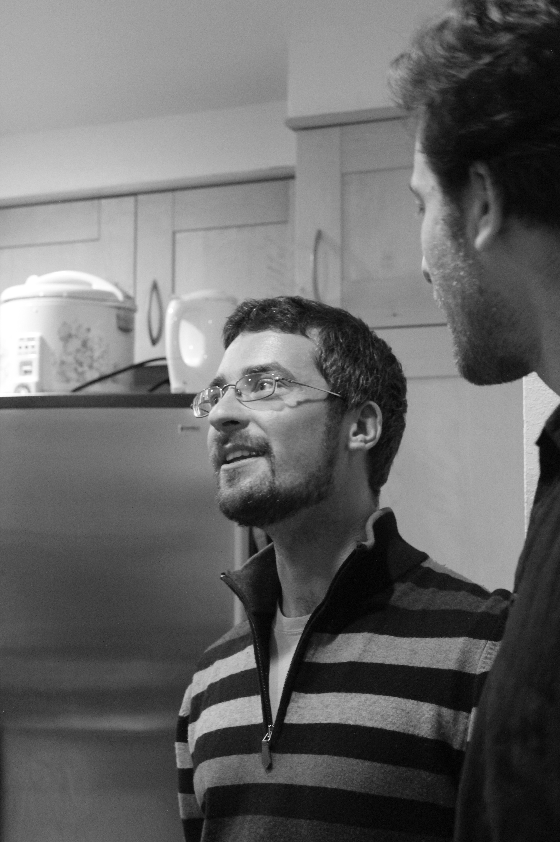

**Nicolas Fedorczak**

*Post doc., 28 years old.*

Nicolas is a French guy and currently looking for a post doc. in the physics field. He works on fusion field… He can choose between 3 different Universities including Louisiana’s University. In order to do the right choice, Nicolas wants to know more about each University: the social life, and the academic research opportunities in the physics field. He likes playing guitar and going to the beach with his friends. But as an abroad post doc. Nicolas would like to meet new friends and discover the American culture.

**1st scenario**

* **Context:** Nicolas does not which University chosen. To be clear about his choice, he wants just in a first time to have some information, like: description of the University, localization.
* **Question:** What’s the background of Louisiana’s University? Where is locate Louisiana’s University? How contact Louisiana’s University?
* **User task:** Nicolas is looking for the main information. He wants to find the description, a map of the University, and then, the phone number.
* **Steps:** 
  + - Click on ‘about us’ on the home page
    - Click on ‘Statement of Purpose’ in order to see the background of the University.
    - Return on the home page and click on ‘contact us’ and then ‘telephone directory’ to have the main campus number.
    - Then, to get the map click also on ‘contact us’ and the small red label ‘map’ on the top navigation bar.

**2nd scenario**

* **Context:** As a post doc. in physics, Nicolas would have more information about the researches in physics and choose the perfect and interesting subject.
* **Question:** What are the current subjects in physics? Are there a complete description and e-mail in order to contact the person in charge? Is there indication about the salary?
* **User task:** In other word, Nicolas is looking for the main page with the description of all post doc. in physics. And he would like to find the basic information necessary for his choice.
* **Steps:** 
  + - **I don’t know where looking for**
    - **Click in research but after physic department in construction**

**3rd scenario**

* **Context:** Like referring in his resume, Nicolas likes playing music and meeting new people. Therefore, he is interesting in the profile area of the University.
* **Question:** Where can I go out? To listen music, to see some concerts and meet people.
* **User task:** Nicolas want to find the main page describing the different activities around the University to hang out. He would find some direct links in order see the price and the schedule of the different attractions.
* **Steps:** 
  + - Click on ‘prospective student’ on the home page
    - Select then ‘area profile’ on the top red navigation bar and click on ‘culture’.
    - You have direct links for different activities in function of the field. For instance, you have ‘fine arts and museum’, ‘music and performances acting’.
    - Go to a particular website to find the schedule and the price

2) Competitive analysis

Ideas// Insert a picture of each home page in order to visualize (gallery)

// Say at the end what will be our navigation and why? For each different section

// Choose 5 websites like said but insert also Louisiana in comparison

**Stanford University**

~ Top navigation item (main navigation) ~

* About Stanford
* Admission
* Academics
* Research
* Life on campus

~ Navigation bar (in function of your status) ~

Gateways for…

* Students
* Faculty & Staff
* Alumni
* Parents
* Visitors
* Neighbors

~ What under about “university name” ~

* Stanford facts
* Visitor information
* Virtual tours
* New & publications
* Offices & administration

~ What under about “academics” ~

* Schools
* Departments
* Interdisciplinary programs
* Academic calendar
* Undergraduate Academic Life

~ What under about “research” ~

* Independent labs
* Research centers
* Libraries
* Undergraduate research
* Accelerator laboratory

~ What under about “Admission” ~

* Undergraduate
* Graduate
* Financial aid
* Professional, continuing, K-12
* Summer session

**Berkeley University**

~ Top navigation item (main navigation) ~

* About Berkeley
* Applying to Berkeley
* Academics
* Research
* Teaching
* Working
* Campus life
* Public service & Community
* Visiting & getting around
* Administration & service

~ Navigation bar (in function of your status) ~

At the top

* Students
* Prospective Students
* Faculty
* Staff
* Cal Parents
* Alumni & friends

~ What under about “university name” ~

* Overview
* Facts at a glance
* National rankings
* Faculty awards and honors
* History of UC Berkeley
* Timeline of discoveries and contributions
* Traditions of cal
* Tours & webcams
* Chancellor & administration
* UC system overview

~ What under about “academics” ~

* Overview
* Academic department & programs (A-Z)
* College & schools
* Corse listings & schedule of classes
* Teaching & learning division
* Graduate division
* UC extension, summer, classes, studying abroad
* Registrar’s office
* Libraries
* Advising & tutoring services

~ What under about “research” ~

* Overview
* Research portal (policies, funding, support)
* Research programs & units (A-Z)
* Faculty expertise database
* Libraries
* Museum & collections
* Research publications
* Undergraduate research office
* seti@home

~ What under about “Apply to Berkeley” ~

* Overview
* Undergraduate admissions
* Graduate admissions
* Transfer, re-entry & student admissions
* Disabled students’ program
* Fees (undergraduate & graduate)
* Financial aid, scholarship & fellowships
* Summer sessions
* Continuing education (UC Berkeley extension)

In comparison with **Louisiana University**

~ Top navigation item (main navigation) ~

* News
* About us
* Academics
* Student life
* Library
* Research
* Athletics

~ Navigation bar (in function of your status) ~

At the middle

* Prospective students
* Current students
* Alumni, donors & friends
* Visitors
* Faculty & staff

~ What under about us ~

* President’s message
* Statement of purpose
* Economic impact
* Sacs-coc reaffirmation of accreditation
* Strategir plan
* University organizational chart
* Fast facts about Ul Lafayette
* Area Profile
* Campus map
* History of the university
* Unique areas of excellence
* Contact us
* Net price calculator
* Voluntary system of accountability (VSA)
* House concurrent resolution 69 performance effectiveness report

~ What under about “academics” ~

* Undergraduate and Graduate Programs
* University Honors Program
* Graduate School
* Distance and electronic learning
* Evening & continuing education
* Academic support for students
* Courses and calendar
* Awards and recognition
* Accreditation and accredited programs
* Contact academic administration

~ What under about “research” ~

It’s an other website but we have in main navigation bar:

* About us
* Sponsored research
* University research council
* Forms
* Office of research and sponsored programs
* Sponsored programs finance administration & compliance
* Intellectual property
* Centers & laboratory
* Research park

~ What under about “Admission” ~

No admission label in the main navigation bar…

1. **Redesign website**

Idea // Bordeaux 2 website: <http://www.univ-bordeauxsegalen.fr/fr/index.html>

System of color interesting in the top navigation bar

No forgot the color white and red

And the symbol of the main picture